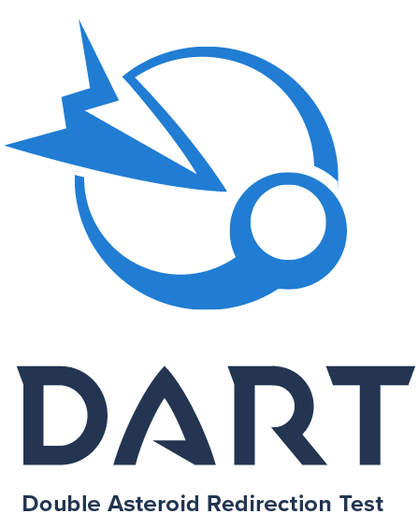

**DART Augmented Reality Experience**



Location:

Date:

Time:

On September 26, 2022, NASA’s Double Asteroid Redirection Test (DART) will do something that has never been done before: crash into the moon of an asteroid — intentionally — to change its orbit. DART is the first-ever space mission to demonstrate asteroid deflection by kinetic impactor. Here’s how you can participate in this unprecedented planetary defense mission.

**BECOME A PLANETARY DEFENDER**

Support the DART mission by becoming a Planetary Defender! Participants who take a short quiz earn a certificate and badge that they can download, print and share on social media.

<https://dart.jhuapl.edu/Planetary-Defender/>

**JOIN OUR WATCH PARTY**

Join our Planetary Defenders Watch Party to experience this unforgettable event as the DART spacecraft approaches and intentionally impacts its target asteroid! There will be hands-on activities, guest speakers, videos, online discussions and more!

<https://dart.jhuapl.edu/watch-party>

dart.jhuapl.edu